Game Programming

Tilemap tutorial

In this series of tutorials I will demonstrate how to build a simple Pac-man like games, where the player will have to evade an enemy and whilst collecting items to increase their score and power ups which will allow them to temporarily kill the enemy.

In this first tutorial I will show you how to create a level for your game using a tileset.

1. The thing you will need to do is import a tileset into your unity project. You can either create these yourself or you may wish to use one from the unity asset store as I have done.

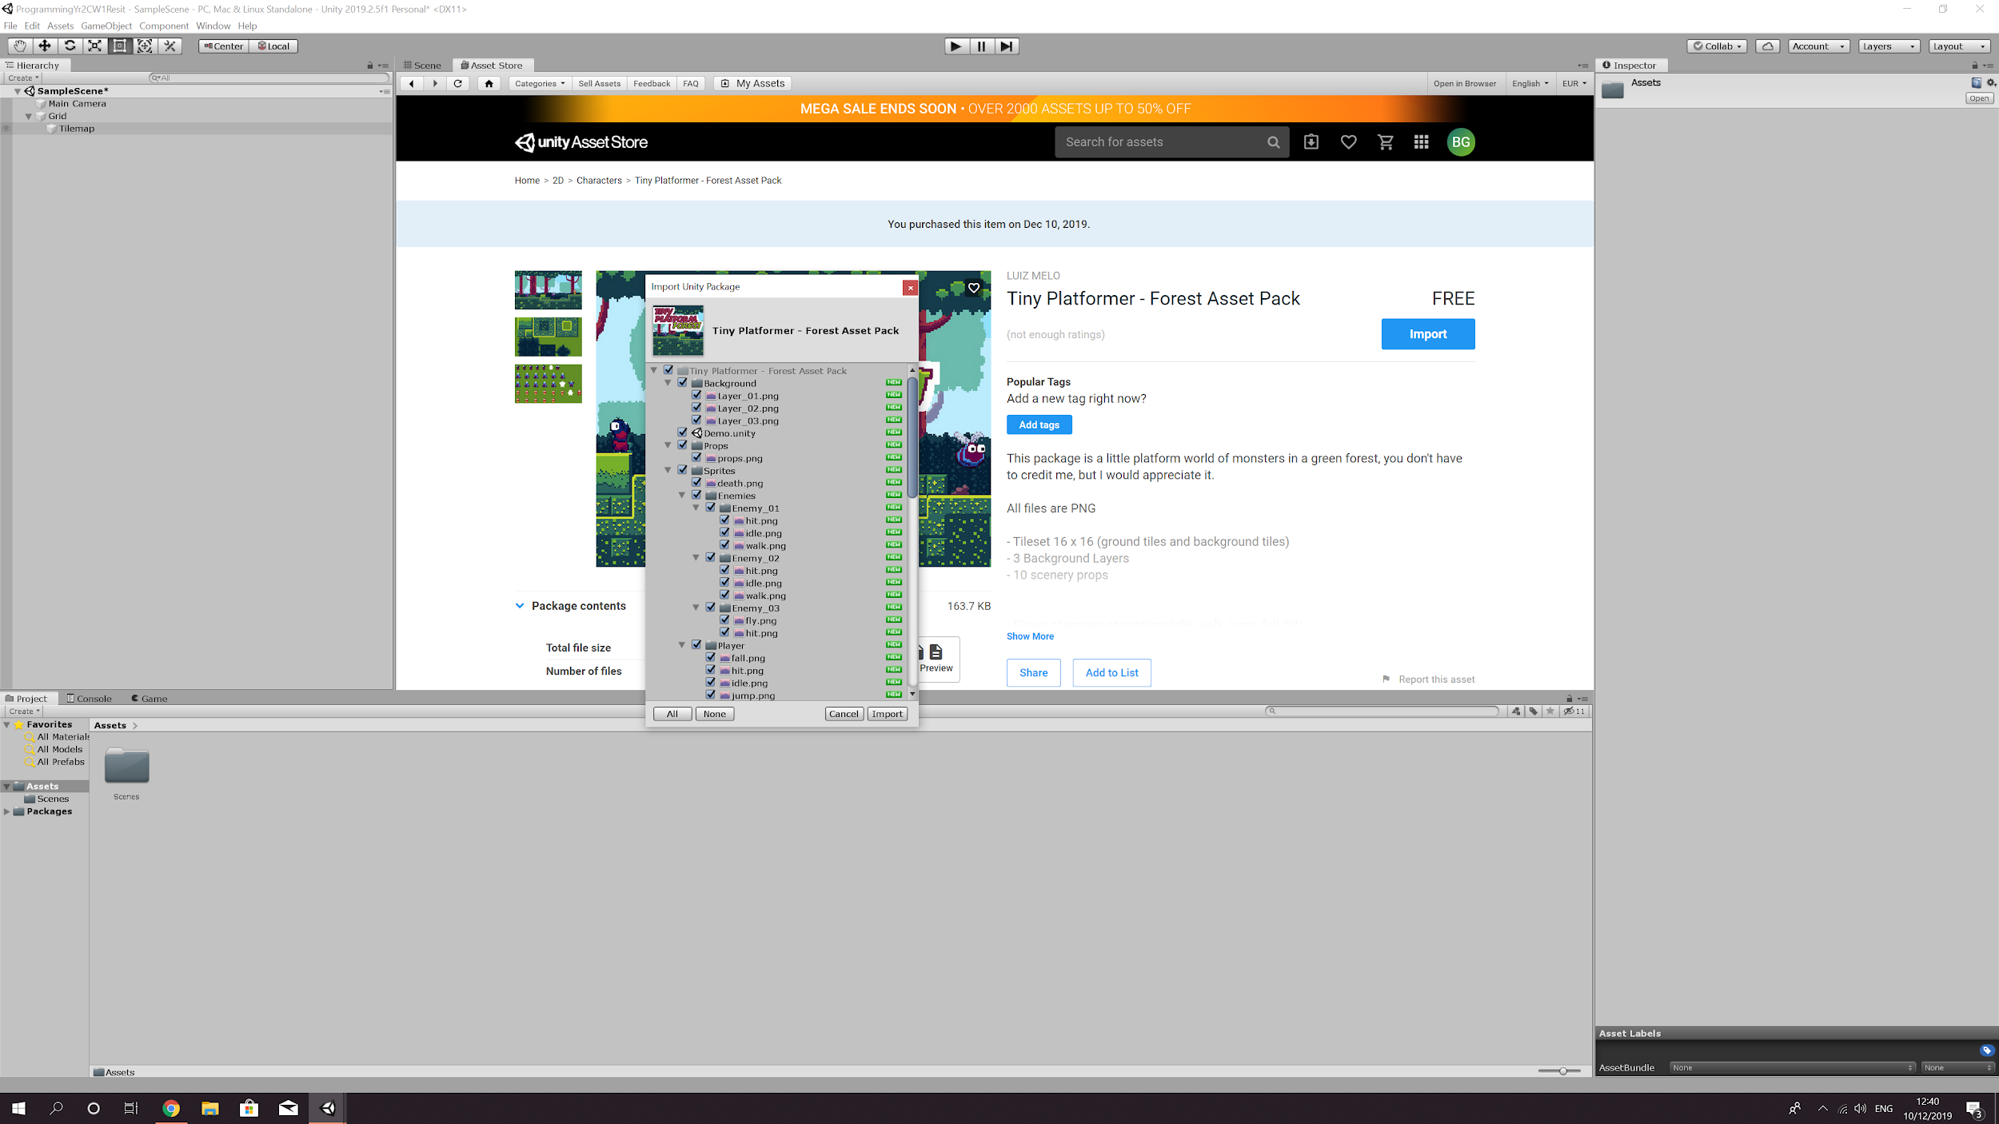

1. Once you have imported the asset list go to Window > 2D > Tile Palette. This will open a window with the tileset ready and available to choose from.

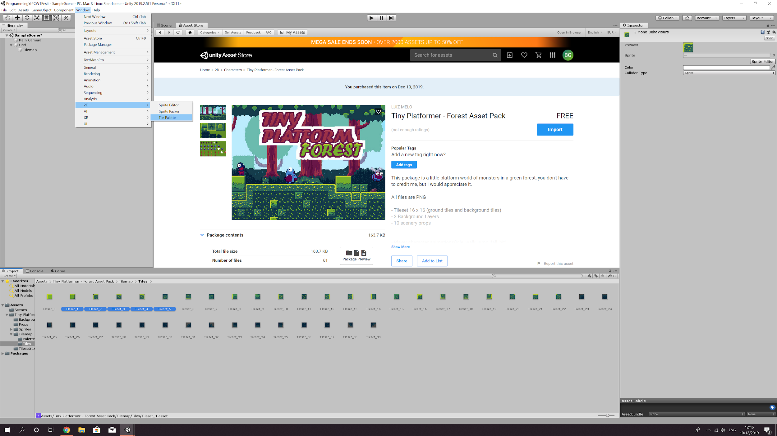

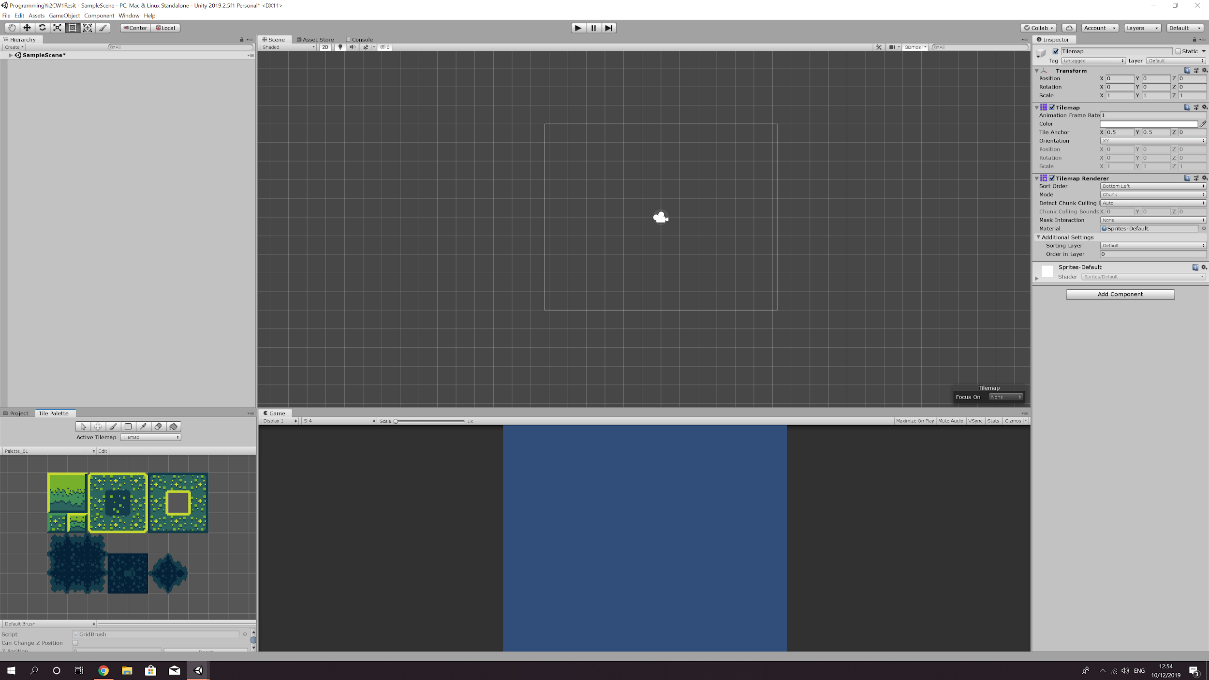

1. To start placing the tiles you will need to create a Tilemap. You can do this by right clicking on the scene hierarchy then 2D Object > Tilemap. This adds a grid to your hierarchy with the tilemap as a child. You should also be able to see the grid in your scene view.

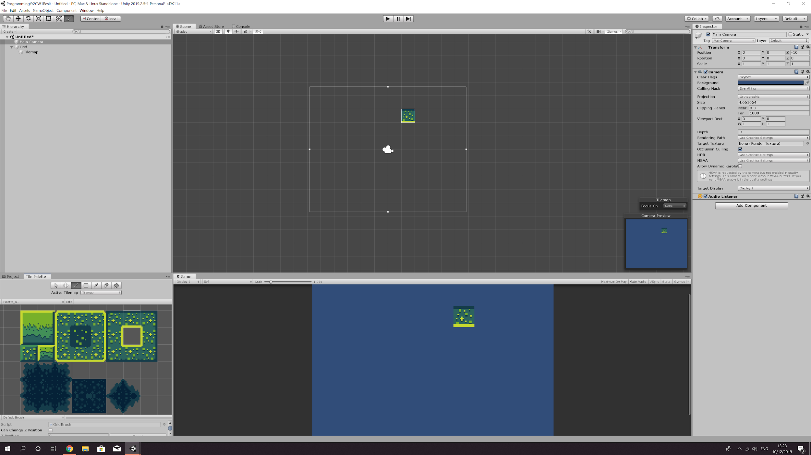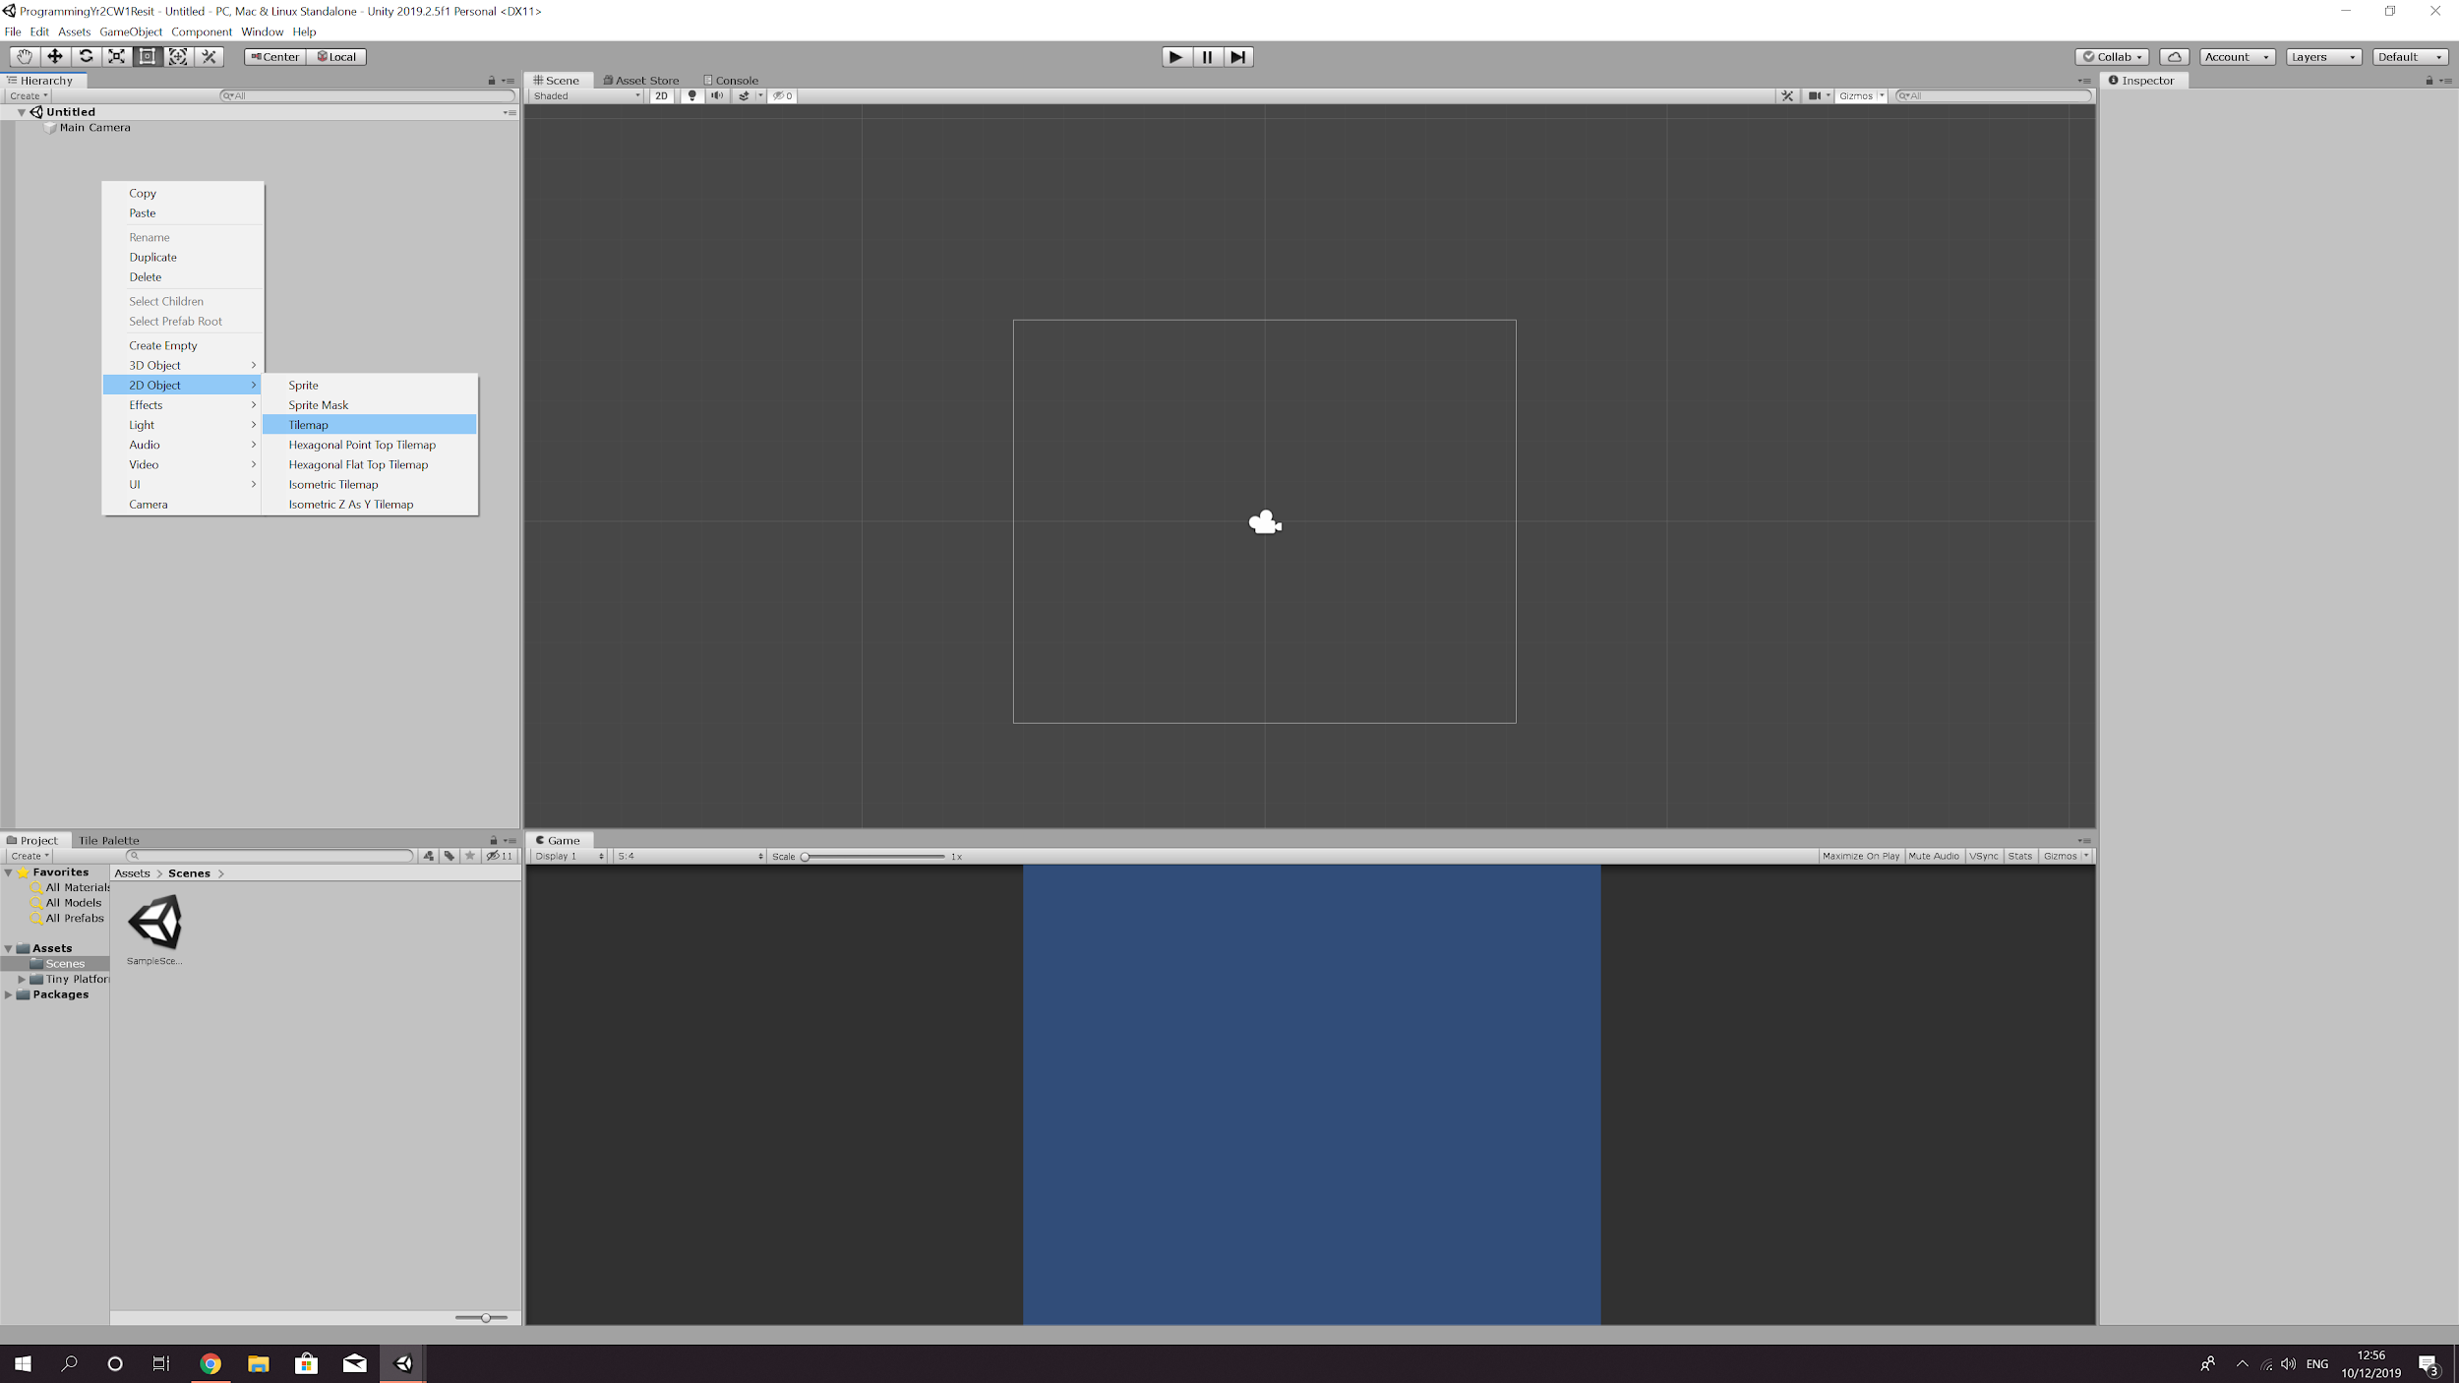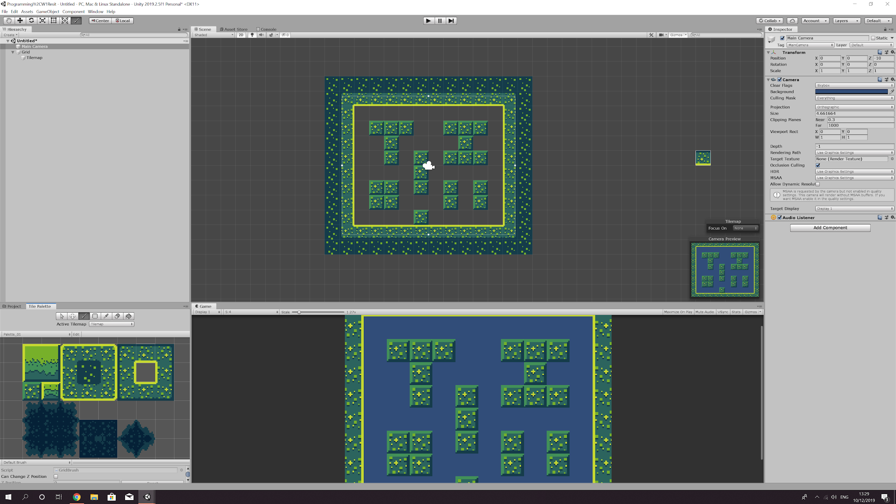

1. Now you are ready to plot you level in the scene view using the Tileset. Go to your Tile Palette, click on the paint brush node and choose the tile you wish to use. Once you have chosen the tile drag your mouse to the scene view where you see your selected tile attached to the cursor. To place the tile left click and it will snap to the grid square.
2. After you have finished plotting your level. You will need to add a collider to each of your tiles. You can do this by going to the Tilemap inspector and clicking ‘add component’. A drop down menu will appear with a search bar, search for ‘Tilemap Collider 2D’.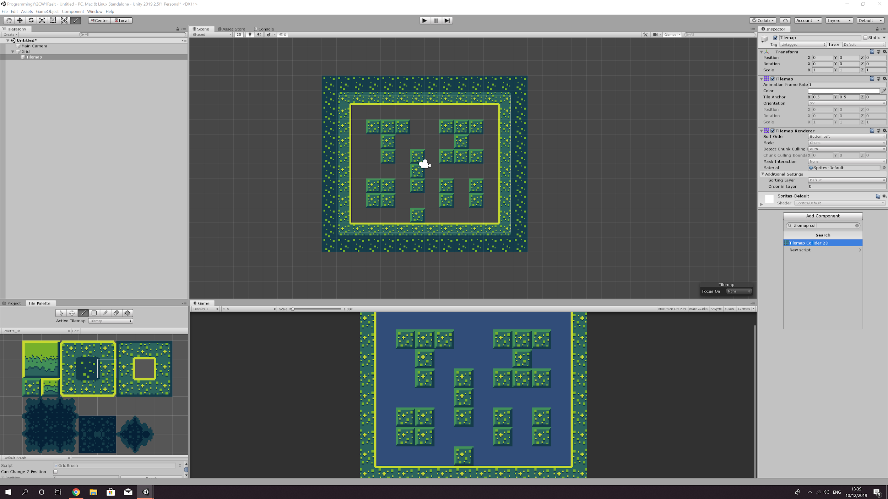

Your level map should now be finished.